Basic Structure of PDA

A pushdown automaton is a way to implement a context-free grammar in a similar way we design DFA for a regular grammar. A DFA can remember a finite amount of information, but a PDA can remember an infinite amount of information.

Basically a pushdown automaton is −

**"Finite state machine" + "a stack"**

A pushdown automaton has three components −

* an input tape,
* a control unit, and
* a stack with infinite size.

The stack head scans the top symbol of the stack.

A stack does two operations −

* **Push** − a new symbol is added at the top.
* **Pop** − the top symbol is read and removed.

A PDA may or may not read an input symbol, but it has to read the top of the stack in every transition.

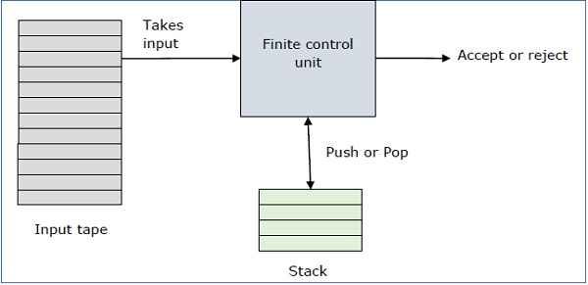

A PDA can be formally described as a 7-tuple (Q, ∑, S, δ, q0, I, F) −

* **Q** is the finite number of states
* **∑** is input alphabet
* **S** is stack symbols
* **δ** is the transition function: Q × (∑ ∪ {ε}) × S × Q × S*
* **q0** is the initial state (q0 ∈ Q)
* **I** is the initial stack top symbol (I ∈ S)
* **F** is a set of accepting states (F ∈ Q)

The following diagram shows a transition in a PDA from a state q1 to state q2, labeled as a,b → c −

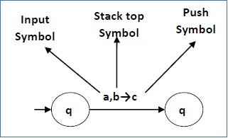

This means at state **q1**, if we encounter an input string **‘a’** and top symbol of the stack is **‘b’**, then we pop **‘b’**, push **‘c’** on top of the stack and move to state **q2**.

Terminologies Related to PDA

Instantaneous Description

The instantaneous description (ID) of a PDA is represented by a triplet (q, w, s) where

* **q** is the state
* **w** is unconsumed input
* **s** is the stack contents

Turnstile Notation

The "turnstile" notation is used for connecting pairs of ID's that represent one or many moves of a PDA. The process of transition is denoted by the turnstile symbol "⊢".

Consider a PDA (Q, ∑, S, δ, q0, I, F). A transition can be mathematically represented by the following turnstile notation −

(p, aw, Tβ) ⊢ (q, w, αb)

This implies that while taking a transition from state **p** to state **q**, the input symbol **‘a’** is consumed, and the top of the stack **‘T’** is replaced by a new string **‘α’**.

**Note** − If we want zero or more moves of a PDA, we have to use the symbol (⊢*) for it.